SHIV SHISHYA PARIWAR

What we are doing :

In the field of spiritualism we are propagating the concept of Jagat Guru Shiva and his discipleness. This concept is one of the most precious Indian spiritual heritage which unfortunately remained only in the books.

It is Revered Varenya Guru Bhrata Sahab Sri Harindrananda Ji who has realized that Lord Shiva acts as Guru. He has propounded three Sutras for becoming a Disciple of Lord Shiva. The Aim of the society is to arouse and create awareness regarding this concept on Global level for the betterment and spiritual upliftment of mankind. In this respect the Seminars, Workshops and Celebrations are being organized and monitored by the Society. The Society is also promoting research work on the different aspects of Shiva and his everlasting impact on the Society and the individual. Seminars and Lecture series and workshops are being arranged and monitored time to time for arousing awareness in the common mass regarding Human Values, Cultural and Spiritual concepts .
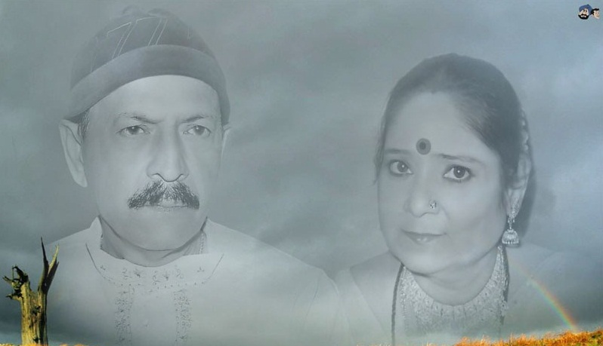

The association is also publishing Literatures in different languages and also making efforts to communicate the concept Worldwide with the help of traditional as well as latest information and communication resources. It also inspires others to celebrate and publish articles regarding the life history of renowned spiritual personalities.
In the field of social welfare the society is making proper arrangement of Meal, Shelter for the poor and needy persons. Medical camps are organized for providing medical help and creating awareness in the field of health and hygiene especially in rural areas.
Society aims at ensuring medical help to human and non human beings. Hospitals will be managed and monitored by the organization or it will help others in this respect.
An integrated effort in the field of ecological preservation, environmental protection is being arranged and monitored by the Organization. The organization is making arrangements for the regular supply of pure drinking water and to create water supply resources in urban and rural areas.

Shiv Shishya Pariwar is regularly organizing various community based programs e.g. Awareness about Stop Female Fetal Murder, Protect Animals, Environment Protection Awareness Programs, Innovative Farming, Seminars on Medicinal Plants, Didi Neelam Anand Education Support Program, Didi Neelam Anand Medical Support Program, Distribution of Sitting Carpets in Government Schools, Free Community Service Camps, Drinking Water Stalls, Rescue Operations, Blanket Distribution Camps, Plantations, Red Cross Trainings, Disaster Management Camps , Tribal Education Support etc.

SHIV SHISHYA PARIWAR®

